International Student Exchange Program 2016-2017
Indian Institute of Management Raipur, India
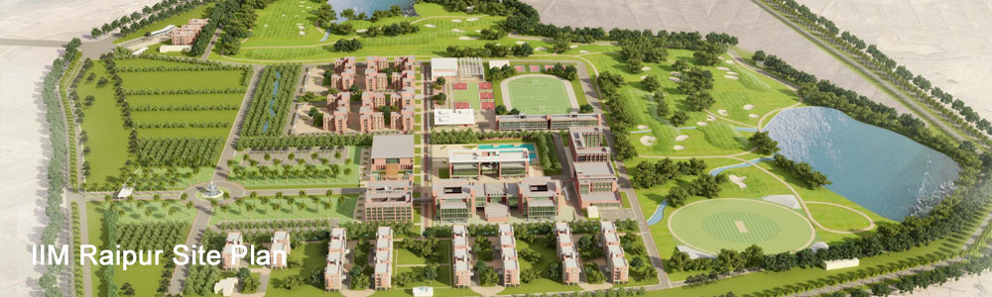

Institution | Indian Institute of Management Raipur
Country | India
Address | GEC Campus, Sejbahar, Raipur, Chhattisgarh, 492015, India
Phone/ Web Site | + 91 (771) 2474702  http://www.iimraipur.ac.in/  https://www.facebook.com/iimraipur
INTERNATIONAL OFFICE
Chairperson  (International Relations) | Prof. Vinita Sahay  Email: chairpersonir@iimraipur.ac.in  Phone: +91 (771) 2474663
Coordinator  International Relations Office | Ms. Bharti Markam  Email: bharti@iimraipur.ac.in/ iro@iimraipur.ac.in  Phone: +91 (771) 2474614  Mr. Ghanshyam Sohoni  Email: Ghanshyam@iimraipur.ac.in  Phone: +91 (2474615)
APPLICATION DETAILS
Please send your Application/ Nomination to us by the Registration Date
Application Periods & Deadlines | Term IV  Registration 11th June, 2016  Orientation Programme 12th June 2016  Class Begin 13th June 2016 – 6th September 2016  Term V  Registration 17th Sept, 2016  Orientation Programme 18th September 2016  Class Begin 19th September, 2016 – 24th Dec, 2016  Term VI  Registration 23rd December, 2016  Orientation Programme 24th December 2016  Class Begin 26th Dec, 2016 – 3rd Mar, 2017
Link for Application  Document Required (all students)  Visa Procedure | http://www.iimraipur.ac.in/iro  - Passport with a valid Student Visa issued by Government of India  - Student Health Insurance for minimum INR 2,00,000  - Letter of approval from (learning agreement) from host Institute  - Latest transcript from the home Institute  - Copy of approved application  - 4 passport sized photographs  - Brief resume/CV  - Health /Vaccination Certificate  All international exchange students will require a student visa to study in Indian institutions, an ordinary tourist visa will not be sufficient. Student visas are issued by Indian Embassy in their home country to bona-fide students who seek to pursue their studies in India. The Visa is generally issued for the duration of the course of study and requires an acceptance letter from Indian Institutions.
ACADEMIC CALENDAR - 2016/2017
Term I – III covers Foundation Courses in Management. Please refer website for details.
Arrival Services | A pick –up service from IIM Raipur is offered only on arrival days.
Activities and Dates | Term IV (June 13, 2016 - September 18, 2016)  Orientation 12th June 2016  Classes Begin 13th June 2016 – 6th September 2016  Mid Term Examination 25th July 2016 – 2th August 2016  Mid Term Result 17th August 2016  End Term Examination 9th September 2016 – 18th Sep 2016  Declaration of End Term Result 10th October 2016  Term V (September 21, 2016 - Dec 10, 2016)  Orientation 18th September 2016  Classes Begin 19th September 2016  Mid Term Examination 28th October 2016 – 6th November 2016  Mid Term Result 21st November 2016  End Term Examination 16th Dec 2016 – 24th December 2016  Declaration of End Term Result 16th January 2017  Term VI (December 14, 2016 – Mar 27, 2017)  Orientation 24th December 2016  Classes Begin 26th December 2016  Mid Term Examination 17th January 2016 – 01th February 2017  Mid Term Result 11th February 2017  End Term Examination 4th March 2017 – 9th March 2017  Declaration of End Term Result 24th March 2017
ARRIVAL INFORMATION
Accommodation | All international exchange students will be provided accommodation in students’ hostel on a dual sharing basis. All rooms are furnished with top of the line furniture. All rooms are connected with Wi-Fi internet connection; the students are required to carry their own laptops.
Other Expenses | Although the students are not required to make the payment of tuition fees, they are however required to bear their living and travelling expense during their stay at IIM Raipur. The breakdown of the expense for the complete term is given below:  - Hostel fees: INR 5000 per month  - Mess charges: INR 4700 per month.  Apart from these fixed charges; students may incur an amount of INR 15,000 per month towards their living expenses in Raipur.
Health Insurance requirements | We advise you to carry a Student Health Insurance for minimum INR 2, 00,000. A medical dispensary is available in the campus where students can consult doctors free of cost.
Bank Account | ATM and bank is available in the Campus.
COURSE INFORMATION
Course Details | Available on our intranet:  http://www.iimraipur.ac.in/prog_pgp_prog_det.htm  (Annexure: List of Elective Courses in Academic Year 2015-2016)
Grading System at IIM Raipur | Letter Grade Grade Points Letter Grade Grade Points  A+ 10 C+ 4  A 9 C 3  A- 8 C- 2  B+ 7 D 1  B 6 F 0  B- 5
Examination | Each elective/foundation course has separate assessment criteria.  Refer Student Handbook for detail information.
English Proficiency | English is the medium of instruction for study at IIM Raipur. Certificate for English Language Proficiency is necessary for acceptance in Postgraduate Programs at IIM Raipur. Students can submit one of these certificates along with their application:  - TOEFL  - IELTS  - English language certificate from own Institute
FURTHER INFORMATION
Number of students at IIM Raipur | Courses Number  Executive Fellow Program in Management (EFPM) 15  Fellow Program in Management (FPM) 15  Postgraduate Program in Management (PGP) 210  Postgraduate Program in Management for Working Executives PGPWE 50  Note: Student Exchange is available at FPM and PGP Program.  For available seats under Student Exchange Program, contact International relations Office at your Institution.
Orientation Program | A short orientation program is organised by International Office in the beginning of each semester (term).
Facilities | Resources Available  i. Library:  http://iimraipur.ac.in/resour_library.htm.  ii. IT infrastructure:  http://iimraipur.ac.in/resour_IT.htm.  iii. Class Rooms :  http://iimraipur.ac.in/resour_class.htm  iv. Gymnasium:  A gymnasium with state of the art equipment has been set-up recently. The fitness centre has weights, ulti gyms, treadmills, cross trainers etc.  v. Wireless System Network (Wi-Fi)  The Campus is fully connected through broadband internet.  vi. Computer lab  Fully equipped computer workstations are available for students’ use.  vii. Cafeteria  A small Cafeteria is available in the campus.
Useful Links | - About IIM Raipur  http://iimraipur.ac.in/about_iimrp.htm  - How to reach Raipur  http://iimraipur.ac.in/about_raipur1.htm

Electives Available in Postgraduate Program in Management, 2016-2017
Indian institute of Management Raipur, India
Term | Electives (Operation & Systems) | Electives (Marketing) | Electives ( HR & OB) | Electives (Finance) | Electives (Strategic Management )
Term IV  13th June 2016 – 6th Sept 2016 | - Project Management  - Service Operations  - Supply Chain Management  - Digital Strategies in Business | - Services Marketing  - Advanced Marketing Research  - Consumer Behaviour  - Sales and Distribution | - Training & Development  - Leadership in Emerging Context  - Compensation Management  - Industrial Relations and Labour Laws | - Security Analysis & Portfolio Management  - Business Analysis & Valuation  - Banking Management and Indian Financial Systems  - International Finance | - Advanced Competitive Strategy
Term V  19th Sept 2016 – 24th Dec 2016 | - Operations Strategy  - Supply Chain Modelling & Analytics  - Global sourcing and Contracts Management  - Business Process Reengineering  - Advanced Production and Inventory Management System | - Integrated Marketing Communications  - B2B Marketing  - Rural Marketing  - Customer Relationship Management  - Brand Management  - New Product Development | - Strategic HRM  - Competency & Talent Management  - Performance Management System  - Organizational Development | - Investment Banking & Financial Services  - Project Appraisal and Finance  - Financial Derivatives  - Merger and Acquisition & Corporate Restructuring  - Financial Risk Management | - International Business  - Strategic Agri-Business Management  - Public Policy
Term VI  26th Dec 2016 – 3rd Mar 2017 | - Lean Enterprise  - Enterprise Solutions  - Logistics Management  - Innovation and Technology Management  - Total Quality Management & Six Sigma | - Retail Management  - International Marketing  - Digital Marketing  - Pricing  - Exports Management | - International HRM  - Role of HR in Merger & Acquisition /Turnaround  - Conflict & Negotiation | - Financial Analytics  - Fixed Income Securities | - Entrepreneurship  - Business Simulation: Capstone  - Econometrics for Managerial Decision Making

Note: Each elective course has 30 contact/lecture/class room hours of study. Each elective course requires additional learning hours outside class. Please refer your Institute policy to convert each course into respective credit system.

