International Student Exchange Program 2017-2018
Indian Institute of Management Raipur, India

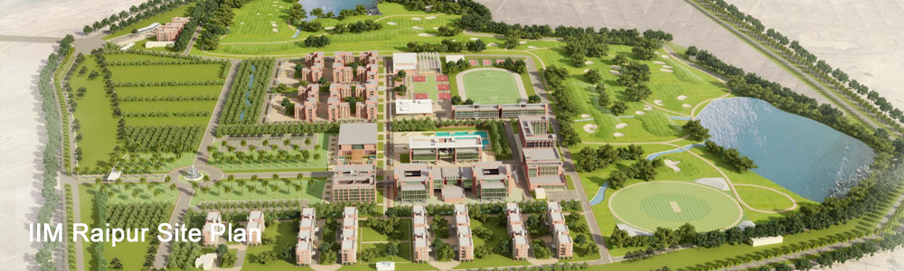

Institution | Indian Institute of Management Raipur
Country | India
Address | GEC Campus, Sejbahar, Raipur, Chhattisgarh, 492015, India
Phone/ Web Site | + 91 (771) 2474702  http://www.iimraipur.ac.in/  https://www.facebook.com/iimraipur
INTERNATIONAL OFFICE
Chairperson  (International Relations) | Prof. Vinita Sahay  Email: chairpersonir@iimraipur.ac.in  Phone: +91 (771) 2474663
Coordinator  International Relations Office | Ms. Bharti Markam  Email: bharti@iimraipur.ac.in  Phone: +91 (771) 2474614

APPLICATION DETAILS
Important Dates | Term V  Nominations Commencement March 2017  Registration 16th September, 2017  Orientation Programme 17th September, 2017  Class Begin 18th September, 2017
Link for Application  Document Required (all students)  Visa Procedure | http://www.iimraipur.ac.in/iro  - Passport with a valid Student Visa issued by Government of India  - Student Health Insurance for minimum INR 2,00,000  - Letter of approval from (learning agreement) from host Institute  - Latest transcript from the home Institute  - Copy of approved application  - 4 passport sized photographs  - Brief resume/CV  - Health /Vaccination Certificate  All international exchange students will require a student visa to study in Indian institutions, an ordinary tourist visa will not be sufficient. Student visas are issued by Indian Embassy in their home country to bona-fide students who seek to pursue their studies in India. The Visa is generally issued for the duration of the course of study and requires an acceptance letter from Indian Institutions.
ACADEMIC CALENDAR - 2017/2018
Term I – III covers Foundation Courses in Management. Please refer website for details.
Arrival Services | A pick –up service from IIM Raipur is offered only on arrival days.
Activities and Dates | Term V (September 18, 2017 - Dec 19, 2017)  Orientation 17th September, 2017  Classes Begin 18th September, 2017  Mid Term Examination** 22nd October 2017 – 30th October 2017  Mid Term Result 20th November, 2017  End Term Examination** 11th Dec, 2017 – 19th December, 2017  Declaration of End Term Result 22nd January, 2018
ARRIVAL INFORMATION
Accommodation | All international exchange students will be provided accommodation in students’ hostel on a dual sharing basis. All rooms are furnished with top of the line furniture. All rooms are connected with Wi-Fi internet connection; the students are required to carry their own laptops.
Other Expenses | Although the students are not required to make the payment of tuition fees, they are however required to bear their living and travelling expense during their stay at IIM Raipur. The breakdown of the expense for the complete term is given below:  - Hostel fees: INR 5000 per month**  - Mess charges: INR 4500 per month**  Apart from these fixed charges; students may incur an amount of INR 15,000 per month towards their living expenses in Raipur.
Health Insurance requirements | We advise you to carry a Student Health Insurance for minimum INR 2, 00,000. A medical dispensary is available in the campus where students can consult doctors free of cost.
Bank Account | ATM and bank is available in the Campus.
COURSE INFORMATION
Course Details | Available on our intranet:  http://www.iimraipur.ac.in/prog_pgp_prog_det.htm  (Annexure: List of Elective Courses in Academic Year 2017-2018)
Grading System at IIM Raipur | Letter Grade Grade Points Letter Grade Grade Points  A+ 10 C+ 4  A 9 C 3  A- 8 C- 2  B+ 7 D 1  B 6 F 0  B- 5
Examination | Each elective/foundation course has separate assessment criteria.  Refer Student Handbook for detail information.
English Proficiency | English is the medium of instruction for study at IIM Raipur. Certificate for English Language Proficiency is necessary for acceptance in Postgraduate Programs at IIM Raipur. Students can submit one of these certificates along with their application:  - TOEFL  - IELTS  - English language certificate from own Institute
FURTHER INFORMATION
Number of student intake at IIM Raipur | Courses Number  Executive Fellow Program in Management (EFPM) 20  Fellow Program in Management (FPM) 20  Postgraduate Program in Management (PGP) 210  Postgraduate Program in Management for Working Executives PGPWE 70  Note: Student Exchange is available at FPM and PGP Program.  For available seats under Student Exchange Program, contact International relations Office at your Institution.
Orientation Program | A short orientation program is organised by International Office in the beginning of each semester (term).
Facilities | Resources Available  i. Library:  http://iimraipur.ac.in/resour_library.htm.  ii. IT infrastructure:  http://iimraipur.ac.in/resour_IT.htm.  iii. Class Rooms :  http://iimraipur.ac.in/resour_class.htm  iv. Gymnasium:  A gymnasium with state of the art equipment has been set-up recently. The fitness centre has weights, ulti gyms, treadmills, cross trainers etc.  v. Wireless System Network (Wi-Fi)  The Campus is fully connected through broadband internet.  vi. Computer lab  Fully equipped computer workstations are available for students’ use.  vii. Cafeteria  A small Cafeteria is available in the campus.
Useful Links | - About IIM Raipur  http://iimraipur.ac.in/about_iimrp.htm  - How to reach Raipur  http://iimraipur.ac.in/about_raipur1.htm

Electives Available in Postgraduate Program in Management, 2017-2018**
Indian institute of Management Raipur, India
Term | Electives (Operation & Systems) | Electives (Marketing) | Electives ( HR & OB) | Electives (Finance) | Electives (GM & Strategic Management )
Term V  18th Sept 2017 – 19th Dec 2017 | - Operations Strategy  - Supply Chain Modelling & Analytics  - Business Models for E-Commerce  - Lean Enterprise  - Enterprise Technology Management  - Service Operations  - Business Process Reengineering | - B2B Marketing  - Rural Marketing  - Customer Relationship Management  - Brand Management  - New Product Development | - Performance Management System  - Competency & Talent Management  - Compensation Management | - Investment Banking  - Project Appraisal Finance  - International Finance & Forex Management  - Mergers and Acquisitions  - Financial Risk Management | - International Business  - Strategic Agri-Business Management  - Entrepreneurship

Note: Each elective course has 30 contact/lecture/class room hours of study. Each elective course requires additional learning hours outside class. Please refer your Institute policy to convert each course into respective credit system.

**Subjected to revision and shall be updated to the partner universities before the nomination process.

