Decomposition Complexity of Graphs and Its Applications
to Analysis of Socio-Economical Systems
Alexander Rubchinsky
NRU «HIGHER SCHOOL OF ECONOMICS»
NRTU «MISIS»

Publications:
1. Rubchinsky, A.: Family of Graph Decompositions and Its Applications to Data Analysis: Working paper WP7/2016/09 – Moscow: Higher School of Economics Publ. House, 2016. – (Series WP7 “Mathematical methods for decision making in economics, business and politics”). – 60 p.
2. Rubchinsky, A.: Divisive-Agglomerative Algorithm and Complexity of Automatic Classifica-tion Problems: Working paper WP7/2015/09 – Moscow: Higher School of Economics Publ. House, 2015. – (Series WP7 “Mathematical methods for decision making in economics, business and politics”). – 44 p.

LATNA, HSE
Nizhny Novgorod
June 23, 2017

PRESENTATION TOPICS

1. Frequency algorithm of graph dichotomy
2. Divisive-agglomerative algorithm (DAA)
3. New statement of decomposition problems
4. DECOMPOSITION COMPLEXITY OF SYSTEMS
5. Analysis of S&P-500 stock market in 2001 − 2009

Frequency algorithm of graph dichotomy

ESSENTIAL STEP
1. Random choice of a pair of different vertices of graph G.
2. Construction of a minimal path (connecting the two chosen vertices so that its longest edge is the shortest one among all such paths) by Dijkstra algorithm. The length of an edge is its current frequency.
3. Frequencies modification. The value 1 is added to the frequencies in all the edges on the path found at the previous substep 2.

ILLUSTRATION OF ESSENTIAL STEP
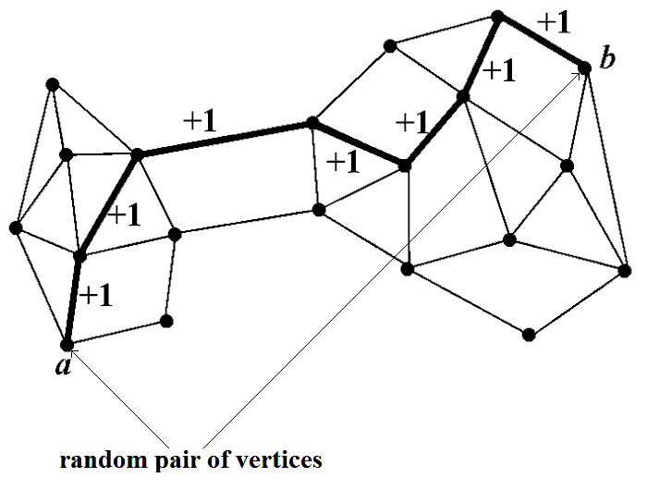

REGULAR CASE
Edges with maximal frequency do not contain any cut of the graph

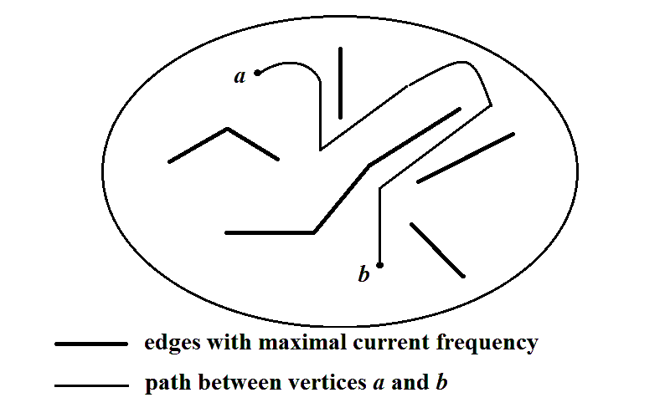

IRREGULAR CASE
Edges with maximal frequency contain a cut of the graph

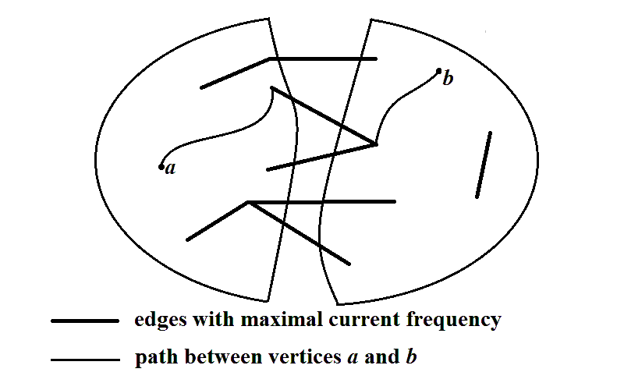
DICHOTOMY ALGORITHM

1. Preliminary step. Initial frequency between 0 and f−1 are randomly assigned to all the edges of the initial graph G
2. Essential step is repeated T times
3. Stopping rule
3.1. Continue essential steps till to the moment of increasing the maximal (over all the edges) frequency F_{max}
3.2. Deduct the value 1 from the frequencies in all the edges forming the last found path.
3.3. Remove all the edges, in which frequency is equal to F_{max}.
The part with the maximal number of vertices is the first part of the found dichotomy. All the other vertices form its second part.
EXAMPLES OF THE DICHOTOMY ALGORITHM
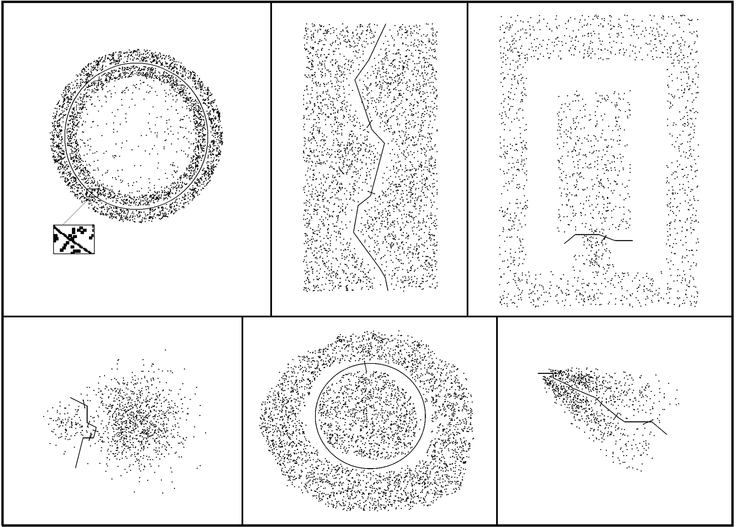
EXAMPLES 2
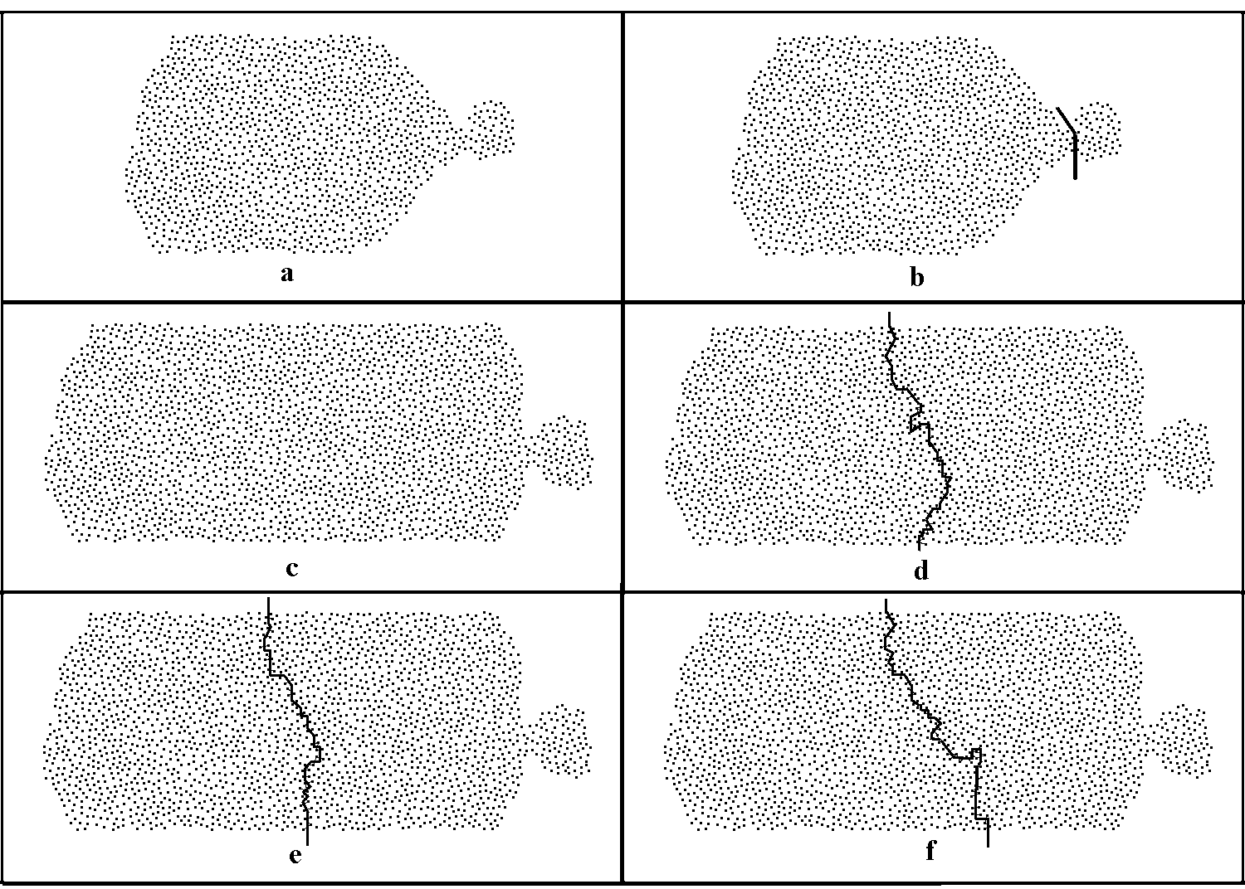
EXAMPLES 3
 | 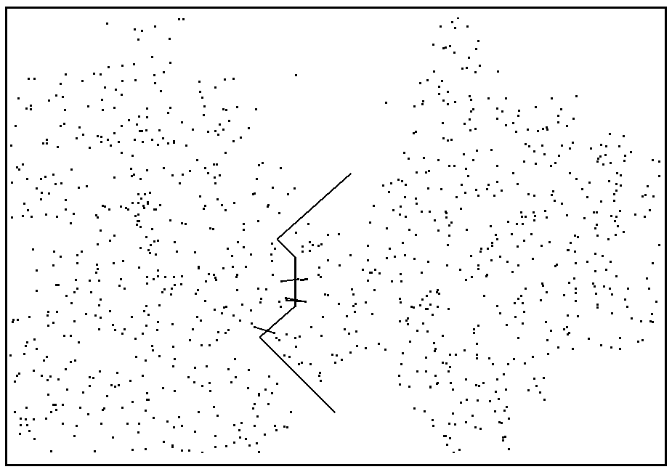
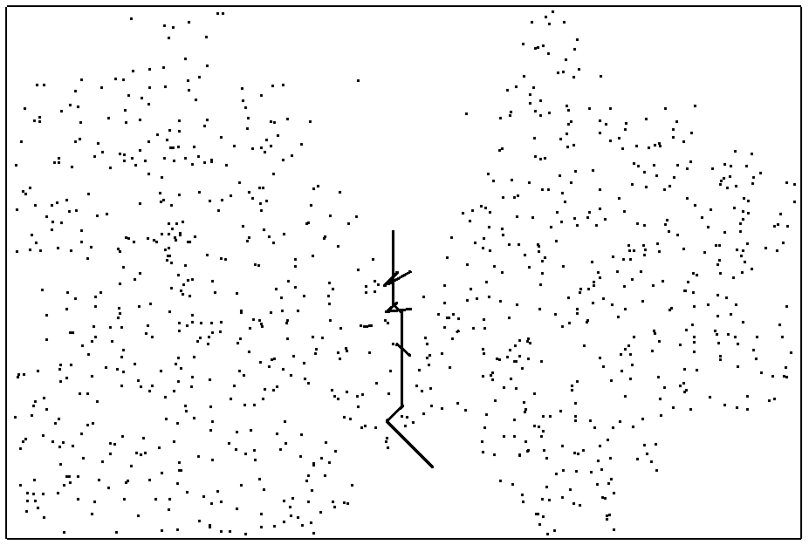 | 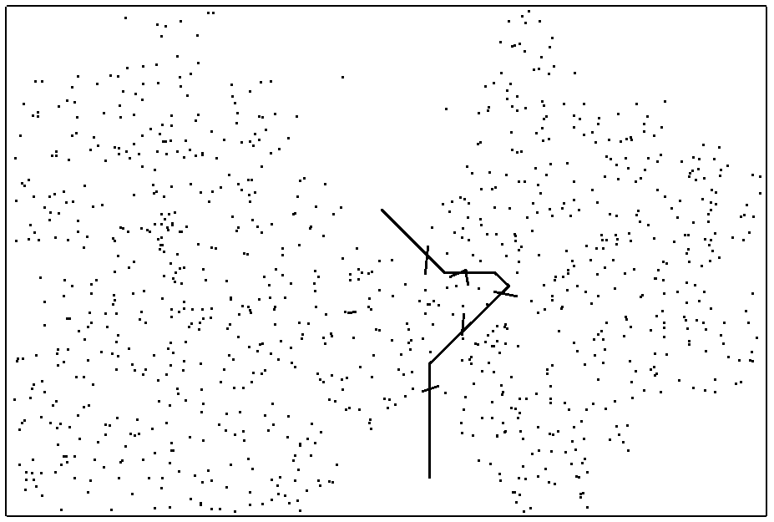

Divisive-Agglomerative Algorithm (DAA) 1

DAA consists of consecutive steps. Every step includes two stages:
- divisive stage
- agglomerative stage
The number k of consecutive steps is the only DAA parameter
The single input of DAA is the initial undirected graph G
The family of decompositions of the initial graph is the output of DAA

Divisive-Agglomerative Algorithm (DAA) 2

DIVISIVE STAGE: graph is divided into two parts; the maximal part is divided into two parts, and so on. The found decompositions are denoted as D₂, …, D_{k}; they are named the essential decompositions.

agglomerative stage: Decomposition D_{j} determines the subfamily of decompositions into j classes (D_{j} itself), into j–1 classes (obtained by the union of subgraphs, connected by the maximal number of edges), and so on, till to decompositions into 2 parts. Denote the constructed decompositions as $L_{j}^{j}$, $L_{j-1}^{j}$, …, $L_{2}^{j}$. These decompositions are named the adjoined ones.

DAA OUTPUT: family of decompositions $L_{2}^{2}$; $L_{2}^{3}$, $L_{3}^{3}$; $L_{2}^{4}$,$L_{3}^{4}$,$L_{4}^{4}$; …; $L_{2}^{k}$,$L_{3}^{k}$, …, $L_{k}^{k}$. The family consists of $\frac{\left(k-1\right)k}{2}$ decompositions: 1 into k parts, 2 into k−1 parts, …, k−1 into 2 parts.

DIVISIVE STAGE

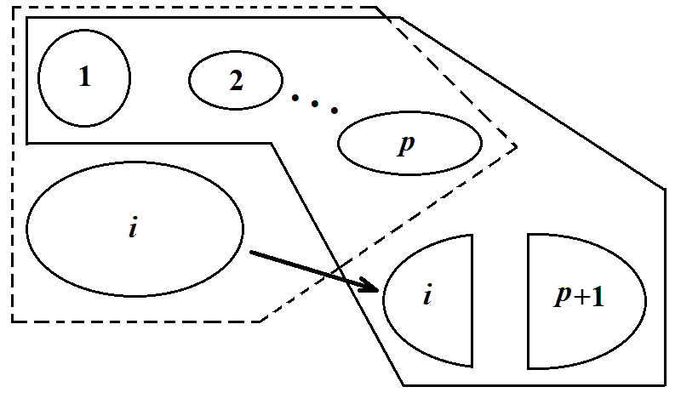
- - - - - decomposition before (p+1)-th divisive stage
────── decomposition after (p+1)-th divisive stage

agglomerative STAGE
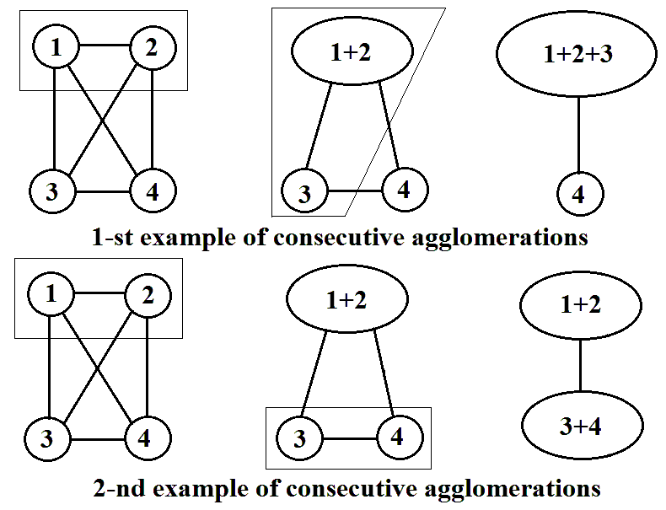

Example of DAA execution
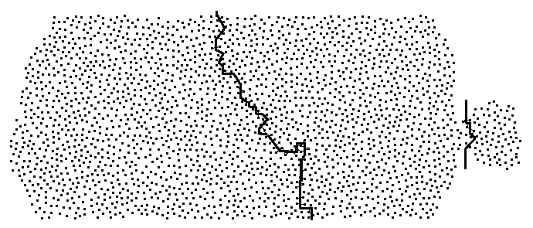

NEW STATEMENT OF DECOMPOSITION PROBLEMS
1. In many cases absence of a single, the most “correct” decomposition is neither a vexatious mistake nor a shortage of a decomposition me-thod. Rather such an absence is an inalienable property of a considered system.
2. Under absence of a single reasonable answer a decomposition prob-lem might consist in:
- construction of a family of divisions of an initial set;
- calculation (starting with the above mentioned family) of a numerical index, expressing complexity of the considered initial problem.
3. The constructed family of decompositions characterizes the initial system. Moreover, in such situations decompositions themselves, forming the above-mentioned family, are of little interest. It turned out that it is much more expedient to focus our attention on calculation of special numerical indices based on these families. The suggested indices describe such properties of the initial system that cannot be revealed by the conventional decomposition approach.

DECOMPOSITION COMPLEXITY OF GRAPHS 1
For a given graph G output of DAA is the family of decompositions $L_{2}^{2}$; $L_{2}^{3}$, $L_{3}^{3}$; $L_{2}^{4}$,$L_{3}^{4}$,$L_{4}^{4}$; …; $L_{2}^{k}$,$L_{3}^{k}$, …, $L_{k}^{k}$. Let us run DAA s times. Denote the family, con-structed at the i-th run, as F(i). Since then all the parameters: f and T of graph dichotomy algorithm, parameter k of DAA and the number s of DAA runs are considered as fixed ones.
Denote as F a larger family of all the decompositions, belonging at least to one of families F(i) (i = 1, …, s).
Because DAA uses random generator, any pair of the decompositions belon-ging to family F, generally speaking, can differ one to another or can coincide one to another.
Assume that in this large family F decomposition d_{p} encounters m_{p} times (p = 1, … , t), where $\sum_{p=1}^{t}{m_{p}}$ = M. Here M – the number of all the decompositions belonging to F – is equal to s × $\frac{\left(k+1\right)k}{2}$ . Define
E = −$\sum_{p=1}^{t}{{\text{μ}}_{p}}\text{ln}\left({\text{μ}}_{p}\right)$, where μ_{p} = m_{p} ∕ M.

DECOMPOSITION COMPLEXITY OF GRAPHS 2

E is the conventional entropy of division of finite family F into parts, consis-ting of coinciding decompositions. It is obvious that the minimal possible value of F(i) cannot be less than 0, while the maximal possible value cannot exceed ln(M).
Assume I = E ∕ ln(M). By the construction, I is a random value. The average value $\overline{I}$ of this random value I is named as decomposition complexity of the initial graph G. Remember that
$\overline{I}$ = $\overline{I}$(f, T, k, s)
In order to find $\overline{I}$ all the operations for calculation I are executed r times. Therefore, the general number of DAA runs is equal to s×r. At the first sight it can seems strange, but the exact value $\overline{I}$ can depend on s and r even for fixed product s×r.
Denote the found estimation of decomposition complexity $\overline{I}$ as D. This estimation depends on several parameters:
D = D(f, T, k, s, r)

DECOMPOSITION COMPLEXITY OF GRAPHS 3

In the framework of the suggested approach different values of decomposi-tion complexity for the same graph are not mistakes but are the kernel of the approach. It does not relate construction of the adequate model of socio-econo-mic systems. The matter concerns the suggested methods of analysis of exact da-ta describing the activity of such systems: votes, shares cost and so on, without any assumptions and hypotheses about human behavior producing just the gi-ven results.
Thus, the case in point is not about models but about data analysis algo-rithms. Therefore, the justification of choice of one or other algorithm parame-ters is not presented as well as justification of choice of algorithms themselves. By contrast with natural science verification in social science is crucially impos-sible – we cannot abolish results of voting in parliaments or trading in stock markets and ask the participants to do the same another time. The only reliable thing consists in common sense and experience of specialists those are seriously engaged in interpretation of presented numerical results.

GENERAL SCHEME OF THE APPROACH APPLICATION

Assume a considered system is described by N numeric vectors. In order to use the suggested approach it is required to execute the following steps:

1. Construction of correlation matrix R =(r_{ij}) (i. j = 1, …, N)
2. Construction of distance matrix D =(d_{ij}) (i. j = 1, …, N) starting with matrix R by the formula
d_{ij} = 1‒ r_{ij} (i, j = 1, …, N).
3. Construction of neighborhood graph G starting with distance matrix D
4. Construction of decompositions family F starting with the graph G
5. Computation of decomposition complexity D starting with family F

If a considered system is already described by correlation matrix, dis-tance matrix or undirected graph, the scheme can be executed from 2-nd, 3-rd or 4-th steps. Therefore there are many situations in which the approach can be expedient. In some situations the dynamic of decomposition comple-xity is more important than the complexity itself.

Analysis of S&P-500 stock market in 2001 − 2010

1. The basic minimal period consists of l consecutive days. All the data about the period x, x−1, … , x−l +1 are related to day x. Here l = 16.
2. Prices of one the share at closure time, considered for days x, x−1, … , x−l+1, form one numeric vector with 16 components. The set of these vectors, corresponding to all the shares, presented at day x in S&P-500 stock market, is the initial set for the above general scheme.
3. Parameters of the scheme are the following ones:
f = 10, T = 3000, k = 2, s = 50, r = 15
4. The decomposition complexity with these parameters was calculated for every day between 01.01.2001 and 31.12.2009 (3287 days). It is presented in the next slides.

2001
0.5778 0.4900 0.8641 0.4164 0.3066 0.4520 0.3593 0.5384 0.7122 0.1347 0.1262 0.3784
0.3248 0.1757 0.1273 0.8358 0.6373 0.8736 0.5200 0.8664 0.8666 0.8676 0.6213 0.6368
0.8734 0.8485 0.5870 0.7396 0.7787 0.4263 0.9582 0.7110 0.1979 0.1072 0.5500 0.6880
0.6094 0.7122 0.5373 0.5716 0.6051 0.6909 0.3604 0.5072 0.6870 0.7127 0.7500 0.6067
0.6609 0.5622 0.7673 0.4103 0.7117 0.6830 0.7468 0.3566 0.2976 0.8206 0.8679 0.7987
0.9246 0.6047 0.5001 0.6446 0.8562 0.1694 0.2692 0.8152 0.6316 0.8020 0.6689 0.7084
0.8672 0.7015 0.5926 0.6358 0.1481 0.0079 0.0480 0.2116 0.3504 0.1963 0.4636 0.0624
0.0029 0.5797 0.7331 0.4901 0.8680 0.8524 0.0622 0.2335 0.1352 0.5567 0.4160 0.4308
0.7797 0.8031 0.8424 0.7891 0.8711 0.8219 0.8265 0.8204 0.2230 0.4815 0.7207 0.4438
0.1792 0.8684 0.8257 0.7351 0.5603 0.3508 0.6057 0.5757 0.0994 0.2453 0.3499 0.3924
0.9844 0.8769 0.6554 0.9570 0.5102 0.4980 0.5068 0.3959 0.5300 0.6548 0.7777 0.8337
0.7906 0.7772 0.6445 0.7109 0.6749 0.7988 0.6909 0.6935 0.3593 0.6290 0.2146 0.2351
0.2600 0.4552 0.4837 0.5479 0.3707 0.7519 0.8104 0.8306 0.4278 0.4931 0.6544 0.6472
0.6468 0.7086 0.4445 0.6277 0.6785 0.4480 0.8008 0.8627 0.7648 0.7146 0.8163 0.6551
0.5090 0.1599 0.2033 0.8978 0.2961 0.3587 0.6883 0.6329 0.2736 0.8423 0.8319 0.9525
0.8395 0.6328 0.2670 0.5106 0.8256 0.7695 0.4829 0.6612 0.3339 0.6304 0.6633 0.2591
0.7096 0.8113 0.8282 0.5064 0.7575 0.6870 0.7146 0.5603 0.8056 0.5411 0.0920 0.4405
0.7081 0.7684 0.8519 0.2052 0.6839 0.8125 0.9429 0.8737 0.8018 0.4309 0.3995 0.4441
0.8053 0.7897 0.8087 0.3125 0.8523 0.7256 0.8415 0.8054 0.4557 0.7885 0.6896 0.1606
0.5130 0.4893 0.4635 0.2544 0.6945 0.7302 0.4488 0.6901 0.3072 0.8110 0.8705 0.8430
0.6919 0.8745 0.6405 0.5275 0.1750 0.3079 0.2053 0.5280 0.1535 0.7434 0.3594 0.1039
0.0000 0.0779 0.3485 0.0755 0.4832 0.4468 0.2036 0.5731 0.8070 0.0499 0.0284 0.0424
0.0136 0.0107 0.0157 0.0539 0.0265 0.7249 0.3263 0.6546 0.8377 0.6319 0.5962 0.7559
0.7460 0.7278 0.8348 0.8602 0.1546 0.5237 0.6860 0.4283 0.3539 0.2509 0.3504 0.0482
0.6595 0.7298 0.5037 0.6209 0.8017 0.8513 0.8144 0.8639 0.4915 0.4930 0.9018 0.8675
0.7486 0.4775 0.6094 0.5086 0.5727 0.3121 0.6609 0.6081 0.0643 0.7002 0.3364 0.5382
0.3253 0.4166 0.1873 0.4749 0.6486 0.6772 0.0462 0.5088 0.7482 0.4777 0.1637 0.1212
0.8419 0.2676 0.5185 0.2472 0.4626 0.1214 0.5935 0.7602 0.9719 0.9081 0.9229 0.9365
0.7939 0.9781 0.6341 0.6228 0.6809 0.7038 0.3305 0.2942 0.2600 0.5924 0.2302 0.7278
0.7055 0.8366 0.2754 0.7802 0.8047 0.8630 0.8109 0.4356 0.7070 0.7281 0.3783 0.4308
0.3930 0.5164 0.4096 0.3864 0.2355

2002

0.4822 0.8682 0.8537 0.7152 0.7632 0.7499 0.7301 0.7163 0.5139 0.5181 0.7938 0.3597

0.7546 0.3742 0.6645 0.5102 0.3227 0.4404 0.7130 0.3262 0.3988 0.3108 0.4875 0.2250

0.4378 0.2991 0.8332 0.8604 0.4523 0.1722 0.6236 0.4369 0.7002 0.6006 0.6327 0.4718

0.8255 0.7679 0.4525 0.4235 0.4584 0.8732 0.6613 0.9090 0.8116 0.9675 0.9119 0.8306

0.8665 0.5317 0.8285 0.5622 0.9073 0.4752 0.8417 0.7500 0.6955 0.7097 0.4294 0.7775

0.5158 0.6903 0.6252 0.3332 0.0700 0.4155 0.0821 0.0907 0.0542 0.1080 0.6959 0.3641

0.8635 0.4764 0.3526 0.2356 0.9126 0.4438 0.4771 0.6619 0.7153 0.4110 0.9272 0.6851

0.7447 0.8851 0.8287 0.8621 0.9016 0.2215 0.8161 0.7390 0.4877 0.8022 0.8498 0.8124

0.6977 0.4000 0.2657 0.6948 0.6702 0.4186 0.1200 0.1306 0.3602 0.7404 0.3706 0.7888

0.6428 0.6899 0.6519 0.7532 0.8308 0.8042 0.5911 0.4979 0.4861 0.2233 0.1198 0.4377

0.2321 0.5233 0.8447 0.5367 0.4871 0.4884 0.3425 0.9080 0.8143 0.9027 0.9221 0.8824

0.5483 0.7847 0.7130 0.8450 0.5527 0.7636 0.7641 0.7183 0.7400 0.6876 0.1783 0.6234

0.8088 0.8298 0.8007 0.7811 0.1751 0.4311 0.5244 0.5606 0.8878 0.6994 0.1241 0.4618

0.1550 0.0935 0.0727 0.0649 0.1877 0.3273 0.1856 0.7092 0.4710 0.5538 0.5812 0.6574

0.9823 0.8707 0.3090 0.5405 0.3685 0.4292 0.7580 0.7225 0.3192 0.6272 0.4408 0.3312

0.5547 0.5300 0.4261 0.0923 0.3600 0.2044 0.4149 0.2108 0.1934 0.5738 0.1292 0.8739

0.2569 0.9199 0.8573 0.4151 0.6365 0.3830 0.0000 0.0236 0.1703 0.1889 0.0180 0.0045

0.0586 0.0260 0.4359 0.5846 0.7020 0.1947 0.5317 0.1228 0.3402 0.1100 0.1938 0.2529

0.6275 0.5222 0.7169 0.5535 0.4457 0.3834 0.4371 0.6621 0.6307 0.0017 0.6606 0.0000

0.3793 0.0260 0.0000 0.2011 0.5330 0.3088 0.6807 0.5090 0.2873 0.1328 0.3655 0.9085

0.4164 0.8533 0.3380 0.5122 0.2758 0.5681 0.6730 0.2851 0.2367 0.8877 0.8806 0.2874

0.7249 0.6473 0.8031 0.6326 0.7258 0.7611 0.7713 0.8370 0.8348 0.7779 0.8484 0.8587

0.6156 0.0521 0.3751 0.0224 0.0527 0.4730 0.7319 0.7618 0.1701 0.4381 0.5751 0.8289

0.8185 0.0692 0.2158 0.2834 0.5399 0.7919 0.3883 0.3968 0.4695 0.5510 0.8691 0.7964

0.6943 0.6395 0.3922 0.0961 0.1096 0.0531 0.3374 0.4589 0.3066 0.3591 0.8681 0.5642

0.2472 0.7769 0.9820 0.9558 0.9700 0.9688 0.9819 0.8991 0.6334 0.5466 0.7900 0.8434

0.4183 0.3668 0.6696 0.5858 0.5441 0.8605 0.3028 0.8744 0.8773 0.8932 0.8560 0.8877

0.3295 0.5928 0.1565 0.3769 0.7178 0.2484 0.2370 0.0644 0.2892 0.5568 0.7999 0.4457

0.3904 0.7838 0.9845 0.9956 0.9426 0.8499 0.2232 0.2845 0.3555 0.5544 0.2010 0.4503

0.3418 0.7254 0.4636 0.5285 0.7717 0.7707 0.7156 0.6454 0.8286 0.0000 0.6714 0.7700

0.8952 0.6842 0.8296 0.6203 0.6538

2003

0.7920 0.7782 0.6523 0.7857 0.1890 0.7449 0.1298 0.4836 0.2666 0.2009 0.2312 0.2963

0.2995 0.7287 0.4964 0.8904 0.8581 0.6807 0.7760 0.8503 0.6379 0.1455 0.4148 0.5733

0.3055 0.0626 0.5700 0.0431 0.0898 0.1605 0.2860 0.7366 0.3232 0.4847 0.8200 0.6039

0.2927 0.4224 0.7891 0.6398 0.5531 0.8159 0.2359 0.0383 0.4719 0.5350 0.2014 0.1724

0.3723 0.7570 0.8511 0.5479 0.8705 0.1579 0.8874 0.7412 0.8292 0.3382 0.6004 0.7618

0.7126 0.6336 0.8053 0.2991 0.8469 0.7785 0.7966 0.8022 0.5629 0.3379 0.4204 0.5693

0.0766 0.0792 0.1260 0.8976 0.8078 0.7555 0.2379 0.2745 0.7232 0.1807 0.0000 0.0504

0.0661 0.9366 0.7244 0.6067 0.6719 0.7566 0.7410 0.1188 0.4866 0.5330 0.1884 0.7962

0.8295 0.7355 0.5304 0.7166 0.7800 0.3350 0.5768 0.7506 0.5415 0.0200 0.2731 0.3775

0.5713 0.7674 0.5996 0.2461 0.7217 0.2857 0.5672 0.3982 0.3263 0.8334 0.9406 0.4699

0.9440 0.6884 0.5929 0.6522 0.6832 0.3493 0.4878 0.3693 0.7732 0.7602 0.4491 0.0000

0.5422 0.5585 0.6462 0.2624 0.6381 0.5748 0.4236 0.3950 0.2964 0.5371 0.8889 0.8327

0.8426 0.8189 0.7722 0.7062 0.7902 0.4270 0.6987 0.0816 0.1872 0.2450 0.0237 0.3581

0.8845 0.5130 0.4658 0.7498 0.2326 0.0265 0.1838 0.2141 0.3910 0.7519 0.7121 0.7850

0.7134 0.8478 0.8193 0.7463 0.5804 0.7375 0.6906 0.8806 0.6743 0.5498 0.6911 0.8856

0.8038 0.4271 0.4760 0.4753 0.4792 0.6594 0.5754 0.5773 0.3922 0.7194 0.5529 0.3578

0.0733 0.0930 0.0941 0.2146 0.3580 0.7739 0.0610 0.5672 0.8145 0.3167 0.8496 0.7592

0.5116 0.6864 0.5449 0.9097 0.9396 0.8893 0.9502 0.9532 0.5484 0.6184 0.9677 0.9617

0.7272 0.3895 0.7225 0.8760 0.8638 0.5878 0.7672 0.8605 0.7262 0.6414 0.7612 0.6853

0.7479 0.8187 0.8551 0.9141 0.4998 0.2072 0.2731 0.1539 0.4886 0.4350 0.6884 0.8623

0.8308 0.6286 0.7535 0.1791 0.9670 0.5992 0.1674 0.1536 0.6423 0.4450 0.7099 0.7989

0.4298 0.5172 0.5632 0.7797 0.5889 0.7335 0.3676 0.3531 0.6705 0.8194 0.8795 0.6753

0.8521 0.7066 0.5154 0.6267 0.0511 0.6988 0.5953 0.6046 0.8828 0.6630 0.7804 0.6397

0.2346 0.1586 0.7741 0.7092 0.1703 0.6110 0.2733 0.1042 0.0718 0.4396 0.0608 0.0514

0.1984 0.2547 0.5373 0.7585 0.4463 0.6381 0.6951 0.5964 0.8455 0.8665 0.8429 0.5175

0.5638 0.5954 0.8643 0.5918 0.7029 0.8554 0.3761 0.1692 0.7445 0.2095 0.6101 0.3009

0.8680 0.3118 0.6210 0.6714 0.5300 0.7912 0.5845 0.4156 0.4162 0.7225 0.6306 0.4086

0.0029 0.5135 0.7086 0.4199 0.2136 0.6669 0.4739 0.7672 0.5034 0.0000 0.0656 0.7032

0.7437 0.0461 0.6414 0.4466 0.3717 0.4213 0.5875 0.6131 0.1632 0.7323 0.5622 0.2919

0.2957 0.4162 0.8011 0.7897 0.7994 0.8744 0.4008 0.7378 0.8179 0.7058 0.5812 0.1835

0.5863 0.7263 0.8305 0.1225 0.4547

2004

0.2205 0.8644 0.4241 0.3278 0.7300 0.9034 0.4991 0.4707 0.4218 0.4508 0.6263 0.4692

0.8652 0.7803 0.5522 0.8654 0.6424 0.5847 0.7142 0.5803 0.5925 0.5472 0.8183 0.2088

0.2875 0.1831 0.5058 0.5766 0.6940 0.8410 0.5508 0.4368 0.5053 0.7684 0.4958 0.5801

0.6379 0.4161 0.3559 0.8167 0.6507 0.8069 0.6199 0.9165 0.0853 0.7123 0.7417 0.4789

0.6687 0.9370 0.8217 0.6000 0.7886 0.6247 0.8223 0.6448 0.4922 0.9012 0.8556 0.4698

0.9016 0.9148 0.5935 0.2153 0.2813 0.6544 0.3583 0.4927 0.3119 0.8142 0.6480 0.8515

0.7295 0.6692 0.2717 0.5669 0.7576 0.7256 0.7307 0.6264 0.3147 0.3698 0.2783 0.1223

0.7858 0.5859 0.5317 0.6604 0.8036 0.9081 0.7229 0.6788 0.5974 0.5711 0.4086 0.2161

0.2026 0.2983 0.0588 0.0614 0.1406 0.1055 0.0000 0.4751 0.6633 0.8192 0.2283 0.5399

0.2429 0.5419 0.7488 0.6557 0.8273 0.6257 0.5314 0.3269 0.8389 0.9276 0.9214 0.6386

0.7015 0.9562 0.9372 0.7709 0.9566 0.6888 0.7413 0.3463 0.6611 0.3215 0.3478 0.4705

0.0000 0.1981 0.1402 0.0479 0.4210 0.3408 0.3216 0.5746 0.8874 0.3736 0.7251 0.8180

0.4333 0.8438 0.8105 0.7861 0.7192 0.6365 0.4033 0.4620 0.4585 0.4090 0.3732 0.8695

0.8701 0.5151 0.7899 0.7174 0.6254 0.8637 0.7912 0.4571 0.6922 0.8632 0.9093 0.3254

0.8234 0.6672 0.4465 0.4529 0.6208 0.3647 0.3011 0.5527 0.4936 0.1351 0.3585 0.5707

0.4310 0.8969 0.0000 0.0888 0.7876 0.7013 0.6332 0.8533 0.8198 0.2488 0.5422 0.5829

0.1698 0.4890 0.6538 0.1435 0.8462 0.7233 0.5205 0.1015 0.1639 0.6684 0.6337 0.8739

0.5077 0.8193 0.8102 0.6930 0.7468 0.1545 0.5136 0.2635 0.3363 0.6261 0.8417 0.7231

0.8681 0.7536 0.7208 0.3574 0.1839 0.2377 0.3311 0.0562 0.1271 0.0186 0.3584 0.0830

0.4133 0.3448 0.4212 0.4158 0.7428 0.5487 0.7676 0.3441 0.1513 0.0000 0.1269 0.2996

0.3115 0.3739 0.2239 0.5907 0.9406 0.2841 0.1116 0.5551 0.2259 0.2537 0.3199 0.2596

0.7268 0.3311 0.2347 0.0264 0.7557 0.3125 0.4993 0.7277 0.7583 0.7492 0.8089 0.5912

0.4452 0.8424 0.6012 0.6925 0.8129 0.5781 0.2395 0.5785 0.7336 0.6086 0.4479 0.5143

0.3033 0.6291 0.4248 0.4900 0.6642 0.1239 0.1482 0.0335 0.1631 0.6157 0.3908 0.3497

0.7754 0.5606 0.4025 0.2979 0.3105 0.5639 0.1720 0.8245 0.2760 0.7011 0.6811 0.7438

0.6664 0.4030 0.7173 0.6500 0.3513 0.1431 0.4846 0.0255 0.1175 0.0258 0.0000 0.0467

0.0000 0.1454 0.0966 0.3666 0.5935 0.3016 0.7411 0.4470 0.6034 0.7433 0.8145 0.3093

0.6767 0.5004 0.0000 0.2503 0.9517 0.4395 0.3427 0.7419 0.8234 0.7105 0.6994 0.6147

0.5840 0.5552 0.3286 0.1246 0.2640 0.6505 0.6630 0.4507 0.3652 0.5786 0.6625 0.3619

0.8562 0.4450 0.6913 0.7871 0.8729 0.8805 0.9172 0.4683 0.3894 0.9356 0.8717 0.7546

0.7993 0.6584 0.6829 0.3252 0.7502 0.4189

2005
0.5308 0.1684 0.7921 0.5671 0.7671 0.7921 0.2102 0.2698 0.0207 0.0916 0.0826 0.2260
0.5261 0.4111 0.5731 0.8061 0.8702 0.2354 0.7704 0.2358 0.4872 0.6803 0.6970 0.8503
0.8633 0.7832 0.7887 0.6916 0.5628 0.2767 0.0000 0.6942 0.8228 0.5572 0.4338 0.1932
0.6000 0.2924 0.2999 0.5638 0.2729 0.0944 0.3484 0.1097 0.4628 0.0839 0.1705 0.4957
0.7043 0.4853 0.4980 0.6470 0.7603 0.6289 0.4613 0.8711 0.5693 0.7372 0.2826 0.8103
0.7181 0.5053 0.7423 0.0968 0.1557 0.0803 0.2066 0.3195 0.6536 0.4924 0.8414 0.8142
0.6617 0.1393 0.6451 0.7592 0.5589 0.7742 0.6668 0.7468 0.8309 0.4215 0.3491 0.3910
0.4660 0.4673 0.3941 0.4761 0.8600 0.3177 0.8528 0.4278 0.3307 0.0000 0.8563 0.7170
0.6988 0.1457 0.3064 0.7668 0.7686 0.7303 0.8494 0.6387 0.5606 0.1071 0.2331 0.4328
0.0000 0.0000 0.1293 0.0000 0.2081 0.7406 0.6626 0.9069 0.6607 0.9177 0.9850 0.6569
0.4377 0.8187 0.7883 0.4023 0.8236 0.5621 0.4364 0.4389 0.5407 0.5551 0.7784 0.3273
0.8054 0.7652 0.1734 0.5361 0.8816 0.4669 0.7607 0.7560 0.6901 0.5733 0.4735 0.4245
0.5794 0.2926 0.0176 0.3162 0.5058 0.4405 0.5475 0.8133 0.4711 0.6710 0.7661 0.7939
0.5151 0.2971 0.6380 0.7344 0.5539 0.6874 0.5413 0.4996 0.8517 0.8063 0.8596 0.5665
0.3604 0.6340 0.7706 0.7261 0.1575 0.4114 0.8895 0.7802 0.7103 0.1569 0.1679 0.6112
0.4701 0.1850 0.6767 0.4616 0.3266 0.8042 0.4533 0.8326 0.7289 0.2287 0.0168 0.1175
0.3027 0.3748 0.7708 0.4103 0.0095 0.2643 0.4494 0.4528 0.4370 0.4915 0.6872 0.6648
0.6847 0.5330 0.7843 0.8151 0.8264 0.1006 0.5392 0.6534 0.7160 0.4435 0.6457 0.5888
0.8265 0.7775 0.5253 0.3262 0.3923 0.2210 0.7191 0.8378 0.1442 0.5945 0.5146 0.5570
0.5810 0.6812 0.1580 0.8235 0.0395 0.0314 0.7477 0.6975 0.5018 0.6459 0.2888 0.3580
0.4085 0.7403 0.6553 0.9059 0.7012 0.8076 0.6158 0.6309 0.4082 0.5714 0.3131 0.7421
0.0000 0.5646 0.4729 0.4543 0.1256 0.3866 0.1955 0.8562 0.7042 0.5324 0.6021 0.5751
0.5609 0.5633 0.3873 0.5890 0.1801 0.4906 0.5312 0.8052 0.7294 0.5535 0.6298 0.0191
0.4941 0.8189 0.8428 0.8450 0.6053 0.5347 0.7718 0.2417 0.1246 0.1277 0.1532 0.0719
0.3073 0.7007 0.4296 0.3483 0.8331 0.2012 0.5382 0.4543 0.4288 0.5184 0.6839 0.8444
0.8630 0.8183 0.6076 0.7494 0.3906 0.4935 0.7597 0.1568 0.3798 0.0965 0.3430 0.7339
0.4030 0.6794 0.6411 0.2985 0.4557 0.5941 0.6557 0.8060 0.3185 0.7017 0.2947 0.3564
0.4819 0.1573 0.1584 0.4431 0.3532 0.0511 0.0000 0.5356 0.3471 0.3599 0.5761 0.1916
0.3491 0.7083 0.2228 0.8598 0.6879 0.6144 0.7068 0.4252 0.8584 0.8395 0.6430 0.5846
0.8211 0.8162 0.6070 0.3342 0.8584 0.5703 0.9057 0.6242 0.4696 0.8474 0.8495 0.8811
0.5245 0.7873 0.7433 0.4862 0.4756

2006

0.7016 0.6035 0.3349 0.9352 0.8176 0.7461 0.6089 0.7177 0.9828 0.0294 0.2621 0.9261

0.5840 0.2738 0.3218 0.1597 0.4552 0.7774 0.5479 0.2535 0.6905 0.8003 0.7412 0.6182

0.8640 0.8617 0.8545 0.3481 0.1987 0.7359 0.0000 0.0898 0.9513 0.8859 0.9563 0.8144

0.7648 0.6975 0.6725 0.9536 0.8774 0.5558 0.5906 0.9722 0.4606 0.8945 0.5242 0.7456

0.8821 0.7454 0.5316 0.7639 0.4768 0.8475 0.4840 0.3380 0.5627 0.5603 0.6806 0.6637

0.5357 0.8511 0.1810 0.0000 0.9134 0.6338 0.7331 0.6985 0.9895 0.7490 0.6901 0.4988

0.3761 0.3654 0.7976 0.6297 0.9135 0.8678 0.5922 0.3898 0.1545 0.6598 0.3064 0.4693

0.4873 0.5862 0.7561 0.5478 0.8868 0.9681 0.7811 0.9058 0.4872 0.8860 0.8253 0.8388

0.6278 0.7943 0.3191 0.3519 0.5886 0.7220 0.6940 0.3338 0.4975 0.2410 0.8841 0.9001

0.9504 0.9539 0.9976 0.5306 0.3672 0.3567 0.6674 0.1585 0.2444 0.3914 0.8650 0.8332

0.8304 0.7987 0.3400 0.7912 0.9930 0.9434 0.8104 0.2244 0.5781 0.6681 0.9127 0.8286

0.6380 0.7368 0.3206 0.5918 0.2140 0.4202 0.1858 0.3403 0.5482 0.5375 0.2090 0.0017

0.7027 0.4254 0.9269 0.9516 0.8196 0.7351 0.5777 0.9318 0.2297 0.3076 0.5170 0.8567

0.1142 0.7486 0.9505 0.1607 0.4358 0.2207 0.3760 0.3159 0.9070 0.3114 0.6918 0.2427

0.4659 0.3220 0.9817 0.9875 0.9019 0.9864 0.9716 0.9702 0.9294 0.7801 0.7511 0.9960

0.8074 0.1455 0.4934 0.3235 0.5839 0.1408 0.4024 0.2007 0.8410 0.8455 0.8695 0.6696

0.6983 0.1774 0.4835 0.5383 0.0648 0.3246 0.0000 0.7567 0.4280 0.3395 0.4876 0.2330

0.2596 0.1008 0.3961 0.9512 0.3425 0.5852 0.0095 0.2287 0.3692 0.3401 0.3041 0.1755

0.5054 0.4302 0.6713 0.9125 0.8439 0.9821 0.5439 0.5969 0.9653 0.3535 0.7926 0.4792

0.9313 0.4669 0.5209 0.3794 0.6002 0.2194 0.0000 0.3468 0.5750 0.9616 0.9240 0.7410

0.8976 0.4414 0.4898 0.9235 0.8035 0.8541 0.8571 0.0604 0.4914 0.2098 0.7416 0.4009

0.8850 0.7157 0.9477 0.8826 0.7411 0.8972 0.5269 0.2583 0.3584 0.4741 0.5021 0.3565

0.4200 0.7755 0.7671 0.9810 0.8855 0.9832 0.9311 0.9724 0.9685 0.6308 0.6903 0.7985

0.4766 0.4997 0.9624 0.7603 0.5993 0.7460 0.3896 0.3601 0.6036 0.6390 0.2042 0.4150

0.9297 0.7176 0.3417 0.2767 0.6573 0.5392 0.7760 0.9611 0.6068 0.4853 0.4874 0.7901

0.1953 0.5411 0.7789 0.4660 0.9060 0.9046 0.9701 0.6635 0.9354 0.9733 0.9216 0.5208

0.6511 0.4167 0.4733 0.9211 0.8926 0.6462 0.4667 0.8198 0.9444 0.9962 0.9619 0.9745

0.5477 0.7387 0.8534 0.6782 0.9428 0.4703 0.6807 0.9325 0.8514 0.4653 0.5532 0.4690

0.2176 0.2741 0.3113 0.3476 0.8215 0.9345 0.4123 0.6532 0.3794 0.8121 0.6380 0.4774

0.1466 0.8888 0.6017 0.9206 0.8886 0.8722 0.7990 0.5897 0.6056 0.4650 0.8602 0.5747

0.5533 0.6554 0.3991 0.0336 0.2255

2007

0.4610 0.8554 0.7735 0.9188 0.9369 0.9532 0.9561 0.5096 0.3281 0.8130 0.3067 0.2763

0.4614 0.6028 0.6062 0.3962 0.3095 0.1833 0.3671 0.6397 0.3271 0.7530 0.3112 0.1132

0.5170 0.3729 0.9295 0.7483 0.4705 0.9205 0.4228 0.6187 0.6022 0.3977 0.3471 0.3117

0.1386 0.2709 0.1717 0.2683 0.3457 0.1593 0.2420 0.6592 0.9373 0.9281 0.8585 0.3607

0.4005 0.7420 0.4646 0.3916 0.8687 0.9271 0.4206 0.8895 0.8565 0.6123 0.4697 0.7466

0.4807 0.1873 0.3215 0.7007 0.6276 0.0017 0.0000 0.0594 0.0395 0.3465 0.5046 0.9033

0.8540 0.9712 0.2894 0.8099 0.8603 0.9108 0.2037 0.8954 0.3034 0.3801 0.9085 0.7225

0.8374 0.4046 0.4920 0.0000 0.4355 0.7187 0.3769 0.6149 0.5407 0.7229 0.7247 0.6104

0.8345 0.9033 0.6622 0.3522 0.4447 0.7631 0.5545 0.8007 0.6916 0.5717 0.7917 0.9549

0.4654 0.6060 0.5311 0.3440 0.3726 0.2370 0.6208 0.6760 0.9561 0.7791 0.7138 0.5473

0.8868 0.8096 0.6905 0.9655 0.6722 0.8797 0.8286 0.8194 0.6975 0.9104 0.4367 0.5587

0.7215 0.8253 0.9758 0.9820 0.9414 0.9537 0.6721 0.4901 0.4300 0.6502 0.4003 0.8826

0.9016 0.5986 0.6640 0.6263 0.9184 0.3980 0.8019 0.6813 0.1768 0.1736 0.9614 0.6876

0.0927 0.9719 0.8402 0.8158 0.8337 0.9434 0.8864 0.8190 0.4072 0.2973 0.4792 0.5804

0.7786 0.2811 0.9507 0.7680 0.5042 0.8463 0.5542 0.5992 0.4663 0.3288 0.3566 0.5654

0.8178 0.6918 0.8130 0.9047 0.9442 0.8465 0.7067 0.3913 0.5817 0.4073 0.7072 0.8809

0.6092 0.6992 0.4638 0.9580 0.6905 0.6462 0.7600 0.5581 0.5701 0.2829 0.3792 0.9784

0.3017 0.5483 0.5232 0.3685 0.6848 0.8735 0.0973 0.7579 0.3337 0.2188 0.0988 0.0217

0.0000 0.3187 0.9156 0.9400 0.8231 0.7710 0.6110 0.3127 0.6757 0.8771 0.8649 0.9892

0.9522 0.9926 0.9602 0.9304 0.6024 0.7815 0.8687 0.7961 0.7029 0.5526 0.8931 0.9644

0.5128 0.9251 0.9533 0.3269 0.6861 0.7015 0.3987 0.9607 0.9845 0.8337 0.2646 0.1035

0.4267 0.6221 0.7334 0.6515 0.5919 0.5914 0.4554 0.5840 0.8934 0.8639 0.8974 0.6198

0.2026 0.4519 0.0336 0.4019 0.5354 0.2884 0.7827 0.8814 0.8492 0.4889 0.7171 0.8362

0.8968 0.8795 0.2030 0.6209 0.2848 0.8078 0.6048 0.7915 0.7761 0.5431 0.4103 0.9020

0.7472 0.5557 0.9129 0.3122 0.2190 0.5088 0.7008 0.3998 0.5118 0.5859 0.7762 0.5893

0.9615 0.5651 0.8405 0.4479 0.3639 0.4782 0.6978 0.8253 0.5025 0.9706 0.6182 0.8083

0.3237 0.4299 0.0062 0.0000 0.3233 0.3323 0.9170 0.3599 0.3903 0.2616 0.4309 0.9816

0.2586 0.5910 0.5300 0.8774 0.7556 0.9500 0.8851 0.7552 0.9956 0.8654 0.5823 0.3898

0.2863 0.2769 0.5520 0.4914 0.0491 0.5871 0.2145 0.0869 0.5373 0.4352 0.9400 0.7104

0.8101 0.5614 0.5573 0.8741 0.1565 0.2491 0.2569 0.3544 0.8199 0.7590 0.9379 0.9772

0.4429 0.9145 0.9728 0.9840 0.5646

2008
0.7933 0.7489 0.2347 0.6334 0.3749 0.1008 0.0648 0.0396 0.1666 0.0404 0.0536 0.3708
0.0374 0.2553 0.5348 0.3971 0.0945 0.6033 0.2441 0.2675 0.1155 0.2326 0.4835 0.5869
0.5274 0.5355 0.3606 0.6400 0.5870 0.5741 0.8341 0.1305 0.5068 0.8322 0.5347 0.9620
0.9942 0.6623 0.1885 0.8518 0.9391 0.4124 0.4495 0.3181 0.4540 0.5652 0.6265 0.6646
0.5932 0.7677 0.3847 0.9606 0.9911 0.9657 0.9575 0.9981 0.6695 0.5227 0.9853 0.5419
0.2396 0.9241 0.6160 0.6596 0.6144 0.4695 0.8811 0.0951 0.1336 0.4585 0.2554 0.6144
0.9372 0.8146 0.6212 0.8889 0.4074 0.9756 0.9823 0.9819 0.6391 0.8235 0.6739 0.4617
0.1835 0.3141 0.1773 0.1735 0.1453 0.5980 0.8527 0.9233 0.9308 0.6288 0.2595 0.1383
0.5574 0.5510 0.9391 0.0591 0.0597 0.8398 0.6097 0.5254 0.7415 0.7067 0.2509 0.7862
0.9136 0.4252 0.6683 0.6140 0.5543 0.6703 0.3473 0.6823 0.0385 0.1486 0.1041 0.2024
0.9551 0.6290 0.3476 0.2673 0.5212 0.3862 0.4566 0.4882 0.8015 0.6718 0.8994 0.5647
0.6097 0.4669 0.7261 0.6366 0.1975 0.8844 0.3534 0.4120 0.0000 0.7931 0.4779 0.4933
0.4232 0.2129 0.4747 0.3353 0.2819 0.1608 0.3365 0.2397 0.4018 0.0269 0.7639 0.5376
0.4998 0.7877 0.6556 0.7686 0.3638 0.9389 0.7755 0.6457 0.1966 0.6095 0.7670 0.9787
0.9546 0.7238 0.4889 0.4534 0.5319 0.8279 0.9121 0.3121 0.2322 0.1197 0.5351 0.2235
0.2335 0.2502 0.2475 0.1927 0.0000 0.2012 0.6860 0.4400 0.1017 0.5215 0.0570 0.1657
0.2683 0.2104 0.5957 0.5355 0.9883 0.8610 0.6221 0.5502 0.1730 0.1017 0.3252 0.6620
0.4505 0.1936 0.0518 0.1500 0.3919 0.1585 0.0141 0.9804 0.8217 0.9820 0.9534 0.9669
0.9254 0.7964 0.8315 0.4875 0.2300 0.2403 0.5438 0.0933 0.0747 0.2690 0.3332 0.7635
0.0355 0.3304 0.5457 0.7942 0.1007 0.2777 0.2050 0.4929 0.5587 0.2655 0.3962 0.3154
0.3912 0.2725 0.5480 0.7275 0.9719 0.8674 0.3384 0.7357 0.4445 0.7772 0.7340 0.7399
0.2038 0.4977 0.7544 0.3773 0.7715 0.7710 0.6144 0.4506 0.3513 0.9534 0.7158 0.9745
0.7866 0.2953 0.6483 0.9799 0.3234 0.9768 0.8517 0.9373 0.9671 0.9679 0.9508 0.9900
0.9948 0.6714 0.0000 0.0000 0.2583 0.7623 0.9473 0.9769 0.4807 0.4175 0.8451 0.9078
0.7214 0.7370 0.6938 0.8180 0.8731 0.6224 0.4538 0.5372 0.3809 0.9106 0.2490 0.6134
0.3682 0.4267 0.1827 0.4812 0.3518 0.8740 0.6411 0.3823 0.0184 0.0273 0.0389 0.3433
0.8166 0.3444 0.1557 0.9602 0.9464 0.9573 0.7032 0.7134 0.2614 0.8027 0.4544 0.0660
0.6330 0.3059 0.9960 0.9818 0.9076 0.0000 0.8153 0.9502 0.7760 0.5931 0.4362 0.0905
0.0000 0.7005 0.9799 0.6514 0.3980 0.2174 0.3933 0.3121 0.4662 0.7262 0.6624 0.4153
0.5513 0.9691 0.6112 0.6512 0.7353 0.8324 0.5743 0.9788 0.9962 0.4470 0.9599 0.3870
0.7443 0.3522 0.3458 0.6328 0.9921 0.5294

2009
0.9572 0.7480 0.2516 0.0000 0.0000 0.5405 0.2670 0.2104 0.8993 0.5924 0.3669 0.6673
0.7621 0.6812 0.9185 0.9699 0.9428 0.6831 0.1563 0.4665 0.0000 0.3087 0.3740 0.3431
0.6020 0.8731 0.8543 0.8367 0.4310 0.9363 0.9434 0.7425 0.9181 0.9682 0.9558 0.5070
0.4569 0.2480 0.8566 0.8955 0.7789 0.5150 0.9100 0.7670 0.9451 0.3900 0.2034 0.9025
0.9859 0.0000 0.6763 0.2006 0.3855 0.0000 0.0241 0.0255 0.6989 0.2328 0.7217 0.4430
0.0000 0.0000 0.1322 0.2563 0.3304 0.5288 0.8212 0.2962 0.0258 0.8778 0.8776 0.7193
0.2846 0.0329 0.0759 0.6559 0.7328 0.7911 0.1836 0.0312 0.7319 0.6859 0.2968 0.3916
0.0033 0.2067 0.2996 0.5069 0.3862 0.0819 0.9948 0.8998 0.5626 0.9452 0.9055 0.2140
0.8854 0.0970 0.2000 0.0822 0.2957 0.1066 0.1351 0.4066 0.2403 0.7101 0.3417 0.6513
0.5410 0.2909 0.1834 0.0797 0.5205 0.9829 0.8478 0.7157 0.8474 0.7098 0.7457 0.9371
0.9145 0.8118 0.9732 0.7368 0.9094 0.6057 0.8774 0.4175 0.1917 0.5589 0.9341 0.3546
0.9412 0.9206 0.7233 0.2376 0.1587 0.4676 0.6419 0.2579 0.0000 0.3953 0.8021 0.5924
0.1426 0.9774 0.9607 0.4218 0.8961 0.6164 0.1980 0.7861 0.7140 0.9910 0.9280 0.5546
0.5887 0.8521 0.8282 0.9589 0.1203 0.4014 0.7193 0.4511 0.6979 0.7212 0.3196 0.1435
0.8961 0.4833 0.3461 0.2978 0.3651 0.1792 0.4657 0.3948 0.5613 0.9496 0.7325 0.9394
0.7664 0.8776 0.4572 0.8957 0.4828 0.4799 0.7081 0.8929 0.7171 0.4706 0.0364 0.4974
0.7341 0.6676 0.2212 0.1683 0.9288 0.8707 0.0406 0.0293 0.9730 0.4218 0.6936 0.1481
0.8274 0.9202 0.9690 0.1976 0.0215 0.1789 0.5216 0.7301 0.3537 0.5465 0.2620 0.6233
0.4352 0.7806 0.2636 0.4007 0.3786 0.5847 0.6803 0.3880 0.7073 0.7220 0.2617 0.7248
0.5786 0.4816 0.4601 0.9053 0.9049 0.8620 0.5629 0.5990 0.7333 0.0511 0.1740 0.2562
0.1391 0.7485 0.0460 0.7835 0.8398 0.8412 0.6127 0.7864 0.0447 0.1045 0.4238 0.9203
0.1168 0.4152 0.3061 0.0017 0.0637 0.2500 0.1775 0.0913 0.1795 0.0000 0.0000 0.0000
0.0635 0.1013 0.1351 0.3343 0.8041 0.7195 0.9057 0.7013 0.9006 0.6706 0.4406 0.2536
0.2211 0.2841 0.3261 0.7487 0.6874 0.7085 0.3652 0.4792 0.6022 0.1990 0.2682 0.0932
0.2362 0.2175 0.0396 0.1219 0.6863 0.7202 0.7890 0.7979 0.6554 0.8158 0.9291 0.9139
0.7164 0.0901 0.9878 0.8953 0.9500 0.8392 0.6064 0.1129 0.9449 0.8317 0.8452 0.8082
0.6995 0.6246 0.7365 0.1672 0.1309 0.3050 0.0267 0.1757 0.1549 0.0506 0.6131 0.7521
0.5438 0.9429 0.1783 0.8849 0.9764 0.9432 0.9553 0.5877 0.2319 0.6329 0.5705 0.2370
0.7480 0.6668 0.6352 0.9109 0.9703 0.7762 0.6094 0.5897 0.6256 0.6157 0.4586 0.4304
0.8208 0.6824 0.7376 0.5255 0.8559 0.7955 0.7446 0.6144 0.5815 0.2705 0.2834 0.5138
0.6810 0.5165 0.5376 0.7368 0.0488

COMPLEXITY PRIOR CRISES

Day | 26.02.01 | 27.02.01 | 28.02.01 | 01.03.01 | 02.03.01 | 03.03.01 | 04.03.01
Complexity | 0.2976 | 0.8205 | 0.8679 | 0.7987 | 0.9246 | 0.6047 | 0.5001
Day | 16.09.08 | 17.09.08 | 18.09.08 | 19.09.08 | 20.09.08 | 21.09.08 | 22.09.08
Complexity | 0.4506 | 0.3513 | 0.9534 | 0.7158 | 0.9745 | 0.7866 | 0.2953

DATA PICTURE

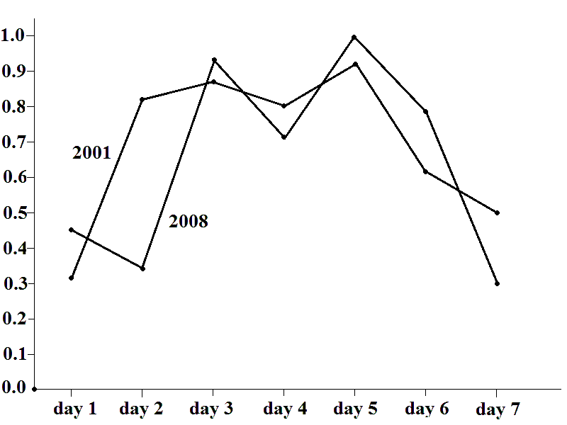

ESSENTIAL INEQUALITIES

variable z_{i} – complexity at day i
(i = 1, 2, …, 7)

z₅ > z₁, z₅ > z₂, z₅ > z₃, z₅ > z₄, z₅ > z₆, z₅ > z₇;
z₃ > z₁, z₃ > z₂, z₃ > z₄, z₃ > z₆, z₃ > z₇;
z₆ > z₇, z₂ > z₁ ─ 0.2;
z₂ < 0.9, z₆ < 0.9;
z₅ > 0.92, z₃ > 0.86.

MAIN QUESTION

Complexities before both crises satisfy
to the above inequality system

How many other days
have the same property?

RECOGNITION MISTAKES

PARAMETERS: f = 10, T = 3000, k = 1, s = 50, r = 15

MISTAKES: 03.04.2003, 06.02.2006, 28.11.2007

PREVIOUS CALCULATIONS

Parameters: f = 10, T = 3000, k = 2, s = 150, r = 10

THE SAME TYPE OF PATTERN PRIOR THE CRISES

Day | 26.02.01 | 27.02.01 | 28.02.01 | 01.03.01 | 02.03.01 | 03.03.01 | 04.03.01
Complexity | 4.887 | 5.854 | 5.981 | 5.757 | 6.028 | 5.351 | 5.175
Day | 16.09.08 | 17.09.08 | 18.09.08 | 19.09.08 | 20.09.08 | 21.09.08 | 22.09.08
Complexity | 5.090 | 4.958 | 6.006 | 5.592 | 6.086 | 5.611 | 4.860

OLD MISTAKES: 13.04.2001, 17.02.2002, 20.08.07

NEW MISTAKES: 03.04.2003, 06.02.2006, 28.11.2007

MISTAKES ARE NOT STABLE WHILE DATA PRIOR CRISES
ARE STABLES RELATIVELY THE ALGORITM PARAMETERS

PROBLEM OF 1987

THERE ARE TWO POSSIBLE ANSWERS:
1. THE SAME PATTERN IS CORRECT
2. THE SAME PATTERN IS WRONG
BOTH ANSWERS ARE REASONABLE

SECOND ANSWER CAN MEAN THE CARHACTER OF STOCK MARKET ESSENTUALLY CHANGED BETWEEN 1987 AND 2001.
INDEED, IN 1987 THE TRADE WAS EXECUTING BETWEEN HUMAN BEINGS AND IN 2001 AND LATER ON – BETWEEN COMPUTER PROGRAMS

GREAT CRASH OF 1929

'My friends at the Vatican told me that the crash was coming and strongly advised me to sell all my American securities. The Catholic Church has the wisdom of twenty centuries behind it and I didn't hesitate for a moment.'
'So when the crash came you were sitting pretty?'
'An Americanism, my dear fellow, which I see no occasion for you to use, but it expresses my situation with a good deal of accuracy. I lost nothing; in fact I had made what you would probably call a packet. '
W. S. Maugham, “The Razor’s Edge”

