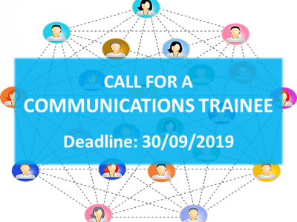

Are you a Master student or a student in the final year of Bachelor programme interested in gaining hands-on experience in the area of communications and event management in an international NGO?

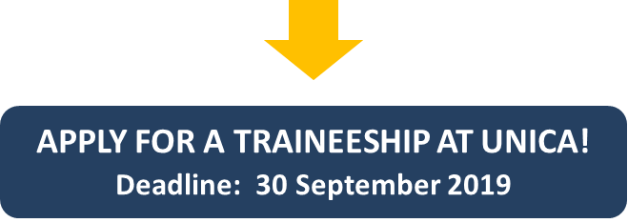

Priority is given to Erasmus+ Placement holders

coming from UNICA member universities

As a trainee, you will take active part in the day-to-day running of our small but multinational office, have a chance to improve your communication & language skills by working closely with our team, and get exposure to the varied activities and projects of our Network that have a real impact on the functioning of Higher Education institutions.

TIME & COMMITMENT
Start date: The internship will start as soon as possible and preferably in October 2019.
Duration of the internship: minimum 3 months. Commitments of longer duration (6 months or longer) are preferred.
Working hours: 30 hours per week (5 days x 6 hours).

LOCATION: UNICA Secretariat, c/o University Foundation, Rue d'Egmont 11, Brussels, Belgium

REIMBURSEMENT OF EXPENSES: Please note that this is a non-remunerated position. Apart from Erasmus+ traineeship grant, our trainees receive a monthly reimbursement of expenses (€350) and a monthly public transportation pass.

DESIRED PROFILE

Priority is given to Erasmus+ Placement holders coming from UNICA member universities

Required:
- Master student or a student in the final year of Bachelor programme in communication sciences, journalism, English language;
- Very good verbal and written command of English;
- Very good writing and communication skills, with an ability to distinguish between formal and informal registers;
- Initiative and enthusiasm to learn, ability to take initiative and to work independently as well as within a team.

Desirable:
- Proven interest in social media & online communication;
- Proven interest in the EU affairs and European policies in the area of Higher Education and Research;
- Basic knowledge of graphic design software (Illustrator, Indesign, Photoshop/Lightroom) and experience in creating simple visual content (announcements, headers and visuals for social media);
- Knowledge of French is an asset.

SUPERVISION: The trainee will work closely with the Project & Communications Officer and other members of the Secretariat team.

TASKS
- Supporting UNICA online publications (websites and newsletter);
- Managing social media accounts (Facebook, LinkedIn, Instagram, Twitter);
- Updating & managing content of the UNICA database and online platforms (staffmobility.eu, UNICA Summer & Winter Schools Portal);
- Supporting the organisation of UNICA events;
- Supporting the management and dissemination of ongoing EU projects in which UNICA is coordinator or partner;
- Occasionally attending Brussels-based events organized by the European Commission, European Parliament, and other partner organisations;
- Other office and/or administrative duties as required.

HOW TO APPLY?
- Please send your CV and a cover letter to: office@unica-network.eu with subject: “Application UNICA Communications traineeship” by 30 September 2019.
- Your cover letter should state clearly your motivation to work at UNICA and your suitability for the position; generic cover letters or applications without cover letters will not be taken into consideration.
- Please note that only shortlisted candidates will be contacted for an interview.

Any questions? Please contact: office@unica-network.eu

