What Australian slang has given the world
Mark Gwynn

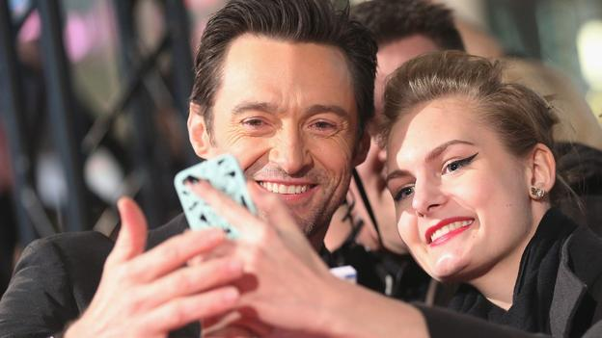
Hugh Jackman takes a selfie at a fan event in Berlin. (Credit: Getty)
The Lucky Country is well-known for its unique turns of phrase. But few realise how many terms in use around the world originated down under, writes Mark Gwynn.
In 2013, ‘selfie’ became Oxford Dictionaries’ word of the year.
It’s become such a ubiquitous word, but few stop to think about where it came from. It may come as a surprise to learn that is has its origins in Australia: the first evidence of the word is use comes from an online forum entry by the Australian Nathan Hope, who posted a photo of his lip, which he says he cut while drinking at a mate’s 21st birthday party.
It’s not the first time an Aussie slang word has made its way into the wider English lexicon. Far from it – Australian slang has influenced the English language around the world, just as Australian culture has been transported to the world by comedians such as Barry Humphries, TV shows such as Neighbours, and actors such as Cate Blanchett and Hugh Jackman.
In the past six months, and throughout this year, Oxford Dictionaries has been steadily updating the Australian English entries to its online dictionary. By the end of this project, some 2,000 words, definitions and phrases derived from or chiefly used in Australian English will have made their way into the venerable online dictionary.
Only some of these will have made their way around the world, but just as Australians have historically borrowed many words an incorporated them into their own variety of English, other English-speakers are now borrowing from the Australian vocabulary.
Greenies, mozzies and pollies
Take ‘selfie’. For most Australian English speakers, the ‘-ie’ suffix is a natural part of the language. Unlike similar diminutives in international English, for example ‘birdie’ or ‘doggie’, the ‘-ie’ suffix in Australian English serves as a marker of informality – providing speakers with a shared code of familiarity and solidarity. Australian English is replete with such words: ‘barbie’ (a barbecue), ‘mushie’ (a mushroom), ‘prezzie’ (a present), and ‘sunnies’ (sunglasses) to name just a few.
A barbecue - or, as the Aussies say, a barbie. (Credit: Getty)
There are a number of these types of abbreviations that have started their life in Australian English and are now to be found in global English: ‘budgie’ (a budgerigar), ‘greenie’ (a conservationist or environmentalist), ‘mozzie’ (a mosquito), ‘pollie’ (a politician), and ‘surfie’ (a surfer).
The Australian penchant for abbreviating words is also demonstrated by the use of the ‘-o’ suffix. In Australian English an ‘ambo’ is an ambulance officer, a ‘reffo’ is a refugee, and a ‘rello’ is a relative. A number of these types of abbreviations have made their way into global English including ‘demo’ (a demonstration), ‘muso’ (a musician), and ‘preggo’ (pregnant). Other abbreviations, including ‘perv’ (a sexual pervert) and ‘uni’ (university), have also migrated to global English.
Perhaps the most well-known abbreviation in Australian English is ‘g’day’. While this abbreviated form of ‘good day’ is recorded from the 1880s, it came to international prominence in the 1980s through a series of tourism advertisements where Australian actor and comedian Paul Hogan invited people from around the world to visit Australia and say “g’day”.
Many English speakers would also know about the common use in Australia of ‘mate’ (a friend, a colleague) and the great Australian adjective ‘bloody’ (used as an intensifier – ‘that’s a bloody good book’). These two words are used elsewhere but are often stereotypically associated with Australian English.
But a number of widely-used words that have either originated in Australian English, or where the first evidence and primary usage is Australian. These include ‘petrolhead’ (a car enthusiast), ‘ratbag’ (a troublemaker), ‘rustbucket’ (a dilapidated car) and ‘wheelie bin’ (a large two-wheeled bin for household rubbish).
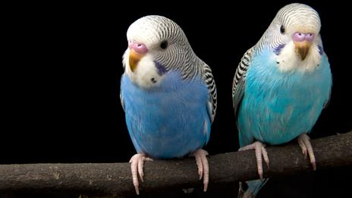
The Australian tendency to add the '-ie' suffix is a marker of informality - and can make many words more managable (such as budgerigar). (Credit: Thinkstock)
Plenty of verbs, too, have Australian origins. Examples include: ‘to crash’ (to go to sleep), ‘to hurl’ (to vomit), ‘to rubbish’ (to denigrate a person), and ‘to stonewall’ (to obstruct a piece of parliamentary business).
They’re a weird mob…
As with other varieties of English around the world, Australian English has its fair share of idioms and phrases that are often unfathomable to the non-native speaker. This is certainly true of idioms including ‘to carry on like a pork chop’ (to behave foolishly; to make a fuss), ‘to chuck a sickie’ (to take a day’s sick leave from work – with the implication that the person is not really ill), and ‘to spit the dummy’ (to lose one’s temper).
But some Australian idioms and phrases have been taken up widely in global English. For example, ‘like a rat up a drainpipe’ (very quickly), ‘no worries’ (an assurance that all is fine) and ‘to put the boot in’ (to attack savagely, especially when the opponent is disadvantaged, or in a manner which in conventionally unacceptable).
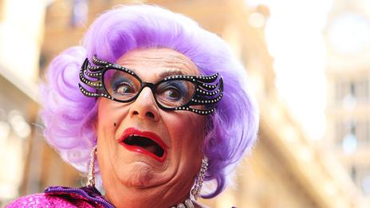
Comedian Barry Humphries created cultural export Dame Edna Everage, as well as a few quirky turns of phrase. (Credit: Getty)
Australian comedian Barry Humphries helped to popularise a number of phrases including some of his own inventions: ‘as dry as a kookaburra’s khyber’ (very dry), and ‘to syphon the python’ and ‘to point Percy at the porcelain’ (both terms for urinating).
Unlike selfie, it’s unlikely these particular phrases will catch on in a big way. But the culture that produced them has contributed many wonderful terms to the world’s vocabularies – and for that we should be ‘rapt as a dunny roll’.

